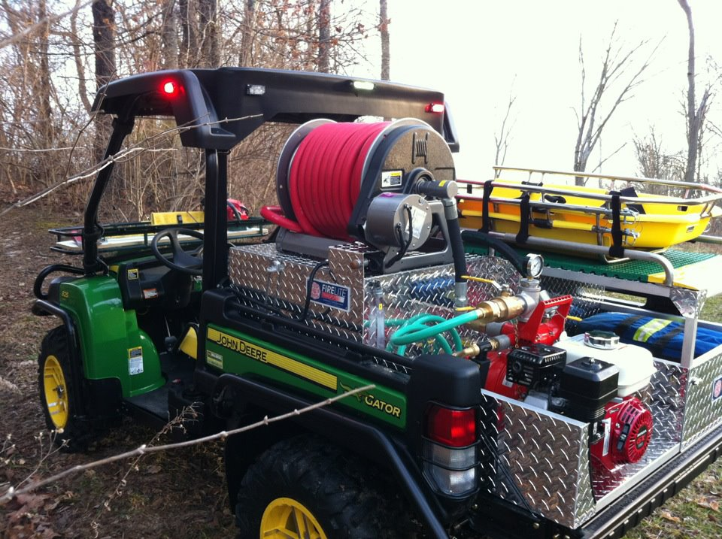

**January 30, 2012**

**Goshen Twp Fire and EMS placed this gater in service just this week and already it has responded out to rescue an injured child in the woods. This gater was purchased with zero tax payer dollars, $25K 100% donations!**